
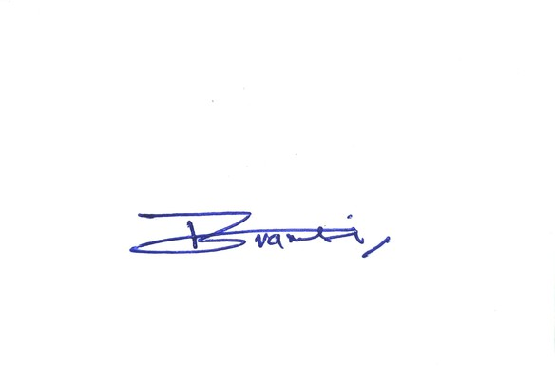

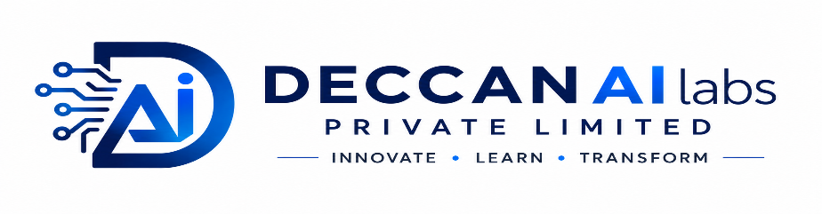
Bengaluru, Karnataka, India


+91 6303207231

careers@deccanailabs.com


https://deccanailabs.com

OFFER LETTER
REG ID: []
Dear [],
We are delighted to welcome you to the 45-Day [] course at DECCAN AI labs Pvt.Ltd.
Congratulations on successfully enrolling in this program. This course has been carefully designed to provide you with practical knowledge, hands-on experience, and industry-relevant skills in the field of []. Throughout the 45-day learning journey, you will gain exposure to modern tools, real-world use cases, guided projects, and structured training that will help strengthen your technical foundation.
We encourage you to actively participate in every session, complete the assigned tasks, and make the most of the learning opportunities provided. Your commitment, curiosity, and consistency will play a key role in maximizing the benefits of this program.
We are confident that this course will enhance your skills, boost your confidence, and prepare you for future academic and professional opportunities. We look forward to supporting you throughout this exciting learning experience and wish you great success in your journey with DECCAN AI labs Pvt.Ltd.
We welcome you to DECCAN AI labs Pvt.Ltd and wish you a productive, engaging, and successful learning experience.

Best Regards,

Founder & Managing Director
Deccan AI Labs

